**Power BI – Assignment III : Connecting Data**

1. ***Data Transformation Output:***

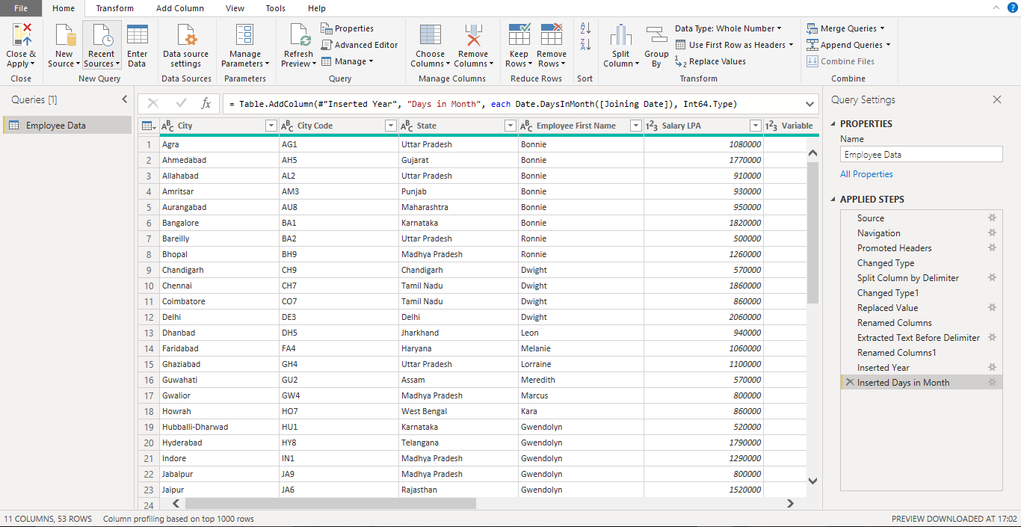

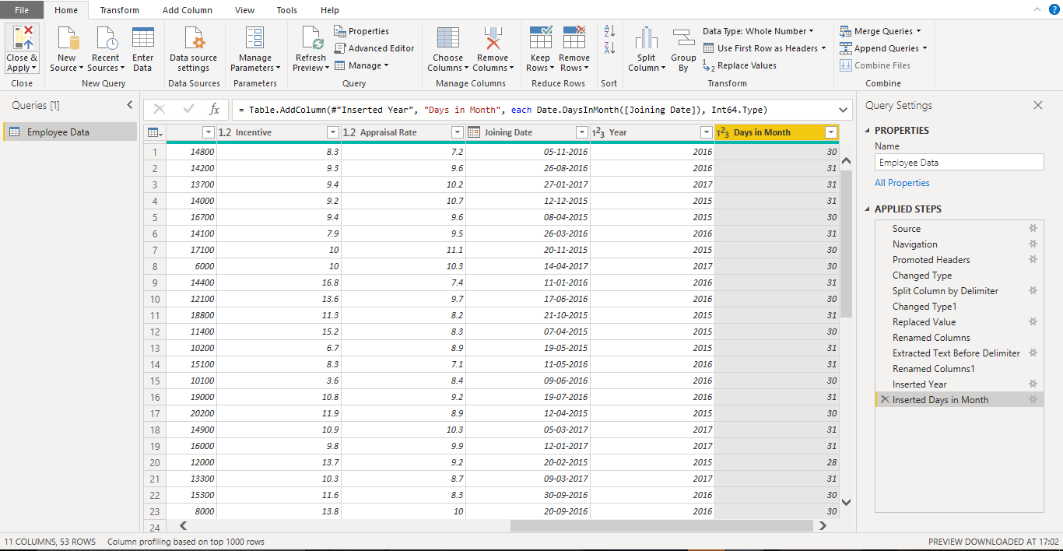

1. ***Screenshot of Final Report :***

